**Common Table Expression**

-- In PostgreSQL, the CTE(Common Table Expression) is used as a temporary result set that the user can reference within another SQL statement like SELECT, INSERT, UPDATE or DELETE.

-- CTEs are temporary in the sense that they only exist during the execution of the query.

-- CTEs are typically used to simplify complex joins and subqueries in PostgreSQL.

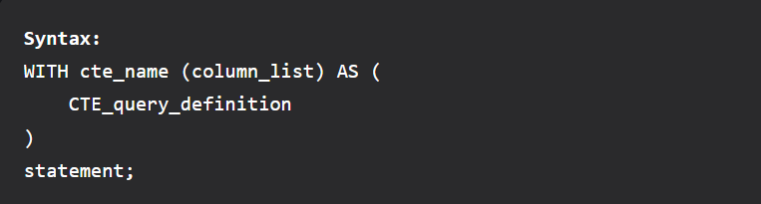

-- The first step is to set the name of the CTE followed by an optional column list.

-- Then we specify a query that returns the result set within the body of WITH clause. if not specified explicitly then the select list of the CTE_query_definition will become the column list of the CTE.

-- Finally use the CTE like a table or view in the statement which can be a SELECT, INSERT, UPDATE, or DELETE.

WITH cte_employee_status AS

(

SELECT employee_id, first_name, last_name,

CASE salary

WHEN 30000 THEN 'Works as fresher'

WHEN 180000 THEN 'Works as Junior Engineer'

WHEN 200000 THEN 'Works as Senior Engineer'

ELSE 'Works as managers'

END AS employee_status

FROM dev_schema.employee

)

SELECT employee_id, first_name, last_name, employee_status

FROM cte_employee_status

WHERE employee_status = 'Works as Junior Engineer'

ORDER BY employee_id;